Contact:
Merril Mascarenhas
Managing Partner
Arcus Group Inc.
Telephone Number: (416) 710-2727
Fax Number: (416) 335-8002
Online: Contact Us

TM

Arcus Group Inc.
1801-1 Yonge St., Toronto M5E 1W7
T 416.335.8000 F 416.335.8002 www.arcusgroup.ca

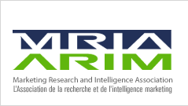
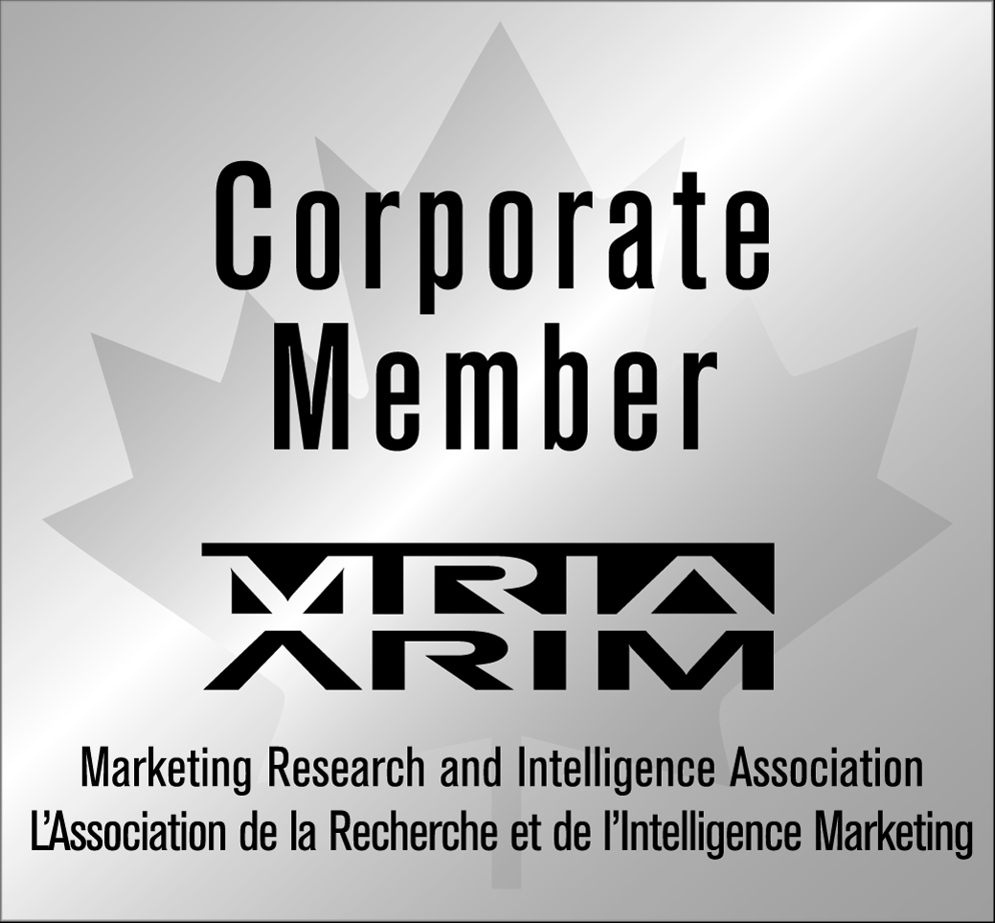
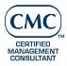
Member

©2020-21 Arcus Group Inc. Statement of Confidentiality: This document contains ideas and information that are privileged and confidential
to Arcus Group Inc. and shall not be disseminated, distributed, or otherwise conveyed to any third party without express written consent.

COVID-19 safety plan

Use this template to document how your organization will keep workers and other people safe at your workplace during the COVID-19 pandemic. How to develop your COVID-19 safety plan: This guide explains what you should think about and gives examples to help you come up with your plan.

Organization details

Business name:
Date completed:
Division/group:
Date distributed:
Revision date:
Developed by:
Others consulted:

Provide information to ensure your employees and vendors know exactly what to do and what to expect.

This plan template will provide your organziation with a document that can be posted on your website or in your workplace.

The plan will act as a reference for employees and vendors who come into the workplace to ensure they comply with safe health related practices.

The COVID-19 pandemic is an evolving situation – review your plan regularly and make changes as required. Refer to the Ontario government’s COVID-19 website for up-to-date information.

1. Educate

Ensure all workers know how to be safe from exposure to COVID-19.

Questions

- What guidance will you need to provide?

- How will you share information? Do you need new or more frequent types of communication?

- Where will you update yourself on new COVID-19 guidance?

Example: Ensure our procedures are up to date by a daily review of Ministry of Health guidance.

Actions:

- [List your actions here. Note who is responsible for each action.]

2. Screen

Develop a screening process for staff and visitors.

Questions

How you will stay current about what symptoms to look for?

Will you use a screening checklist?

Who will do the screening?

Who needs to be screened and how often?

Example

To find out if workers are well when they come to work, we will ask each worker basic questions about their physical health and symptoms using the provincial list of COVID-19 symptoms.

Actions

- [List your actions here. Note who is responsible for each action.]

3. Control

Develop protocols to control the risk of transmission in the workplace.

Include how you will maximize distance and separation, reduce transmission from surfaces and objects, and support good hand and respiratory hygiene.

Questions

What engineering and administrative controls will you use?

What changes will you make?

Who needs to be in the workplace?

How will you gather worker ideas about different ways of working?

Example

We have a new policy that limits time in the kitchen to 10 minutes, we have created a new outdoor break area in our parking lot and have changed how we schedule shifts and breaks.

Actions:

- [List your actions here. Note who is responsible for each action.]

What if:

There is a potential case, or suspected exposure to, COVID-19 at your workplace.

Consider:

What is the contact information for your local public health unit?

What are your isolation procedures?

How will you gather workplace contact information for public health contact tracing?

Example:

We have designated a safe isolation area in the workplace and created a checklist with the procedures of what to do if some gets sick at work, including key contact numbers.

Actions:
- [List your actions here. Note who is responsible for each action.]

How to manage risks

How will you manage any new risks caused by changes to the way you operate your business?

Consider

With workers, review existing critical risks and whether work practice changes will affect your current risk management strategy.

Are any new risks introduced due to changes in worker numbers or work practices?

What new risk controls are required?

Example:

We will establish regular check-ins with workers about how they’re coping with the change to shift work.

Actions:
- [List your actions here. Note who is responsible for each action.]

How will you make sure your plan is working?

Consider:

How often will you schedule a review of your plan? How will you get input and ideas from workers and clients? Who is responsible for evaluating how things are working and for adapting the plan as you find better/easier ways to do things? How will you communicate changes?

Example:

We will set up a weekly meeting between the CEO and the health and safety representative.

Actions:

- [List your actions here. Note who is responsible for each action.]

COVID-19 safety plan – snapshot
This snapshot can be posted in a place where it can be seen easily so your workers, clients and other people entering the workplace will know what actions are being taken.

Business name:
Date completed:
Division/group:
Revision date:

Measures we’re taking

How we’re ensuring workers know how to keep themselves safe from exposure to COVID-19

- [List your measures here.]

How we’re screening for COVID-19

- [List your measures here.]

How we are controlling the risk of transmission in our workplace

Physical distancing and separation

- [List your measures here.]

Cleaning

- [List your measures here.]

Other

- [List your measures here.]

Contingency Plan

If there is a potential case, or suspected exposure to, COVID-19 at this workplace

- [List your measures here.]

How we’re managing any new risks caused by the changes made to the way we operate our business

- [List your measures here.]

How we’re making sure our plan is working

- [List your measures here.]

About Arcus

Arcus puts Clients First.
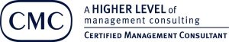
Founded in 2005, Toronto based Arcus is a leading market research and strategy consulting firm that surrounds clients with services to deliver better results. Arcus is consistently rated in the top 1% of firms for client satisfaction, delivered outcomes and business performance metrics. As a member of the Canadian Association of Management Consultants in good standing, Arcus complies with global standards in professional services.
Arcus is the only consulting firm with consultants averaging over 22 years experience, twice the industry average. This allows the firm to offer clients deep sector knowledge and unrivaled functional expertise that only experienced senior level leaders can deliver. Arcus is trusted by hundreds of hundreds of private, public, government and non-profit clients across 36 industry sectors.

A leading research and strategy consulting firm
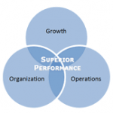
Arcus is a leading research and strategy consulting firm whose mission is to help senior management solve their most challenging problems related to growth, organization and operations. The firm applies a fact-based, structured technique to solve problems. Arcus is a trusted advisor to clients. We understand that clients want small, nimble consulting teams of seasoned people who have years of knowledge and experience. And they want practical, highly targeted information and insights to address their needs.

Service coverage
The variety, breadth, and depth of the projects where Arcus can be a resource are made unique by each client’s specific needs. By providing a very small sample of projects we’ve completed, we can help you understand how and when to use our services. Visit the links below to find out more about a specific problem or opportunity you would like to address.
- Growth and Strategy
- Human Resources
- Transformational Change
- Non-Profit Sector
Below is a sample of the range of services that Arcus has provided to clients.
- A survey of 2,350 consumers and 1,320 business leaders for feedback on sustainability trends
- Architecting a multi-year change strategy for a Fortune 500 company
- Mentoring a CEO on organizational change
- Excellence transformation of a leading B2B services company
- Creating a new sales deployment model for a healthcare company
- Developing a position evaluation and compensation model for a professional medical association
- Improving services to customer segments by deepening their understanding of customer attitudes

“Arcus manages to consistently deliver tangible results on market research and strategy projects. They combine deep business expertise, powerful research capabilities, and innovative thinking to deliver substantial value.”
– Vice President, Nikon

Media Coverage
Arcus has been quoted extensively in media on a range of topics and can offer research studies, insights and ideas. Here are some examples from the Globe and Mail, CTV, Global TV and others.
- Nordstrom countdown to opening begins – Toronto Star
- No lineups outside stores in five years – BNN
- Black Friday retail, marketing, and cross-border shopping trends – BNN
- Does global expansion need a local flavour? – Globe and Mail
- Art of the Pitch – Protect company’s interests when approaching giants – Globe and Mail
- Off-the-shelf technology or a custom design? – Globe and Mail

